ORACLE PRODUCT EVALUATION METHODS

Achieving superior product quality is a prime British American Tobacco objective. Therefore, product sensory and physical quality testing is a fundamental tool to ensure that our key products meet the consumer expectations. On-going monitoring of sensory/physical product quality performance vs. key competitors is fundamental to:

- Confirm competitive positioning of product performance

- Detect erosion of product quality consistency

- Indicate improvement potential/directions

- Detect changing consumer requirements

- Detect competitor product modifications

The following diagram describes the Oracle Product Evaluation methods. These will be divided in two categories: Product Sensory Evaluation and Product Physical Evaluation:

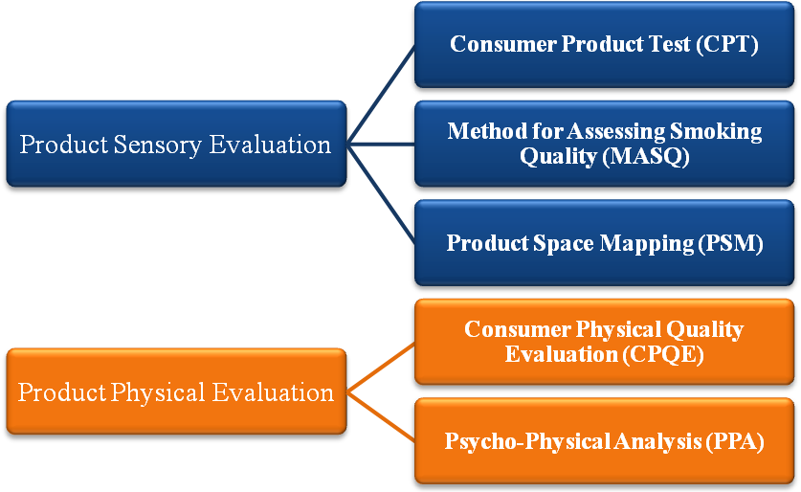

ORACLE PRODUCT PHYSICAL EVALUATION METHODS

Manufacturing-led definitions of product physical quality represent the basis of any quality commitment, by ensuring the consistency of the manufactured item. This is the clear objective of the BAT Finished Product Inspection System (FPI). However, it is equally clear that manufacturing quality systems must be extended to fully address consumer needs.

Manufacturing quality control is rightly focused on the physical integrity of the manufactured item rather than its performance in use. However, these guidelines are usually insensitive to the impact that consumer type, sensory, branding and pricing effects are likely to have on perception of the product by the consumer.

It is therefore necessary to complement manufacturing guidelines with information on consumer requirements and sensitivities in relation to the product, in order to avoid the costs involved in over or under-controlling product attributes or, indeed, failing to identify the importance of certain product attributes for the consumer.

The measurement of consumer quality requirements implies the understanding of the attributes that are taken to be important in the judgement of cigarette physical quality, the ideal level of these attributes and the corresponding tolerance variability level. In this context, the perceptual differences between various consumer segments must also be addressed.

Oracle Product Physical Evaluation methods can be divided in two:

- Consumer Physical Quality Evaluation (CPQE)

- Psychophysical Analysis (PPA)

The following document is the Oracle Protocol for Psychophysical Analysis (PPA).

ORACLE PSYCHOPHYSICAL ANALYSIS (PPA)

CONTENT |  |  |  | PAGE
1. |  | RATIONALE |  | 4
2. |  | OBJECTIVES |  | 4
3. |  | OUTLINE OF THE METHOD |  | 4
4. |  | THE PRINCIPLES OF PSYCHOPHYSICS |  | 5
5. |  | PRE-REQUISITES OF PPA |  | 7
 | 5.1. |  | PPA IN THE CIGARETTE CONTEXT | 7
 | 5.2. |  | PREPARATION OF EXEMPLARS | 7
 | 5.3. |  | ATTRIBUTES TO BE TESTED | 8
6. |  | METHODOLOGY |  | 8
 | 6.1. |  | INTERVIEW STRUCTURE & RATING PROCEDURE | 8
 | 6.2. |  | DEFINITIONS OF ATTRIBUTES & REJECT LIMITS | 10
 | 6.3. |  | SAMPLING | 10
7. |  | ANALYSIS |  | 11
 | 7.1. |  | SOFTWARE | 11
 | 7.2. |  | PROCEDURE | 11
 | 7.3. |  | DECISION CRITERIA | 14
8. |  | APPENDICES |  | 15
 | 8.1. |  | STANDARD ATTRIBUTE LIST | 15
 | 8.2. |  | QUESTIONNAIRES AND STIMULI EXAMPLES | 15
 | 8.3. |  | FULL CASE EXAMPLE | 15

LEGAL NOTICE

Any reference in this document to "young", "younger" or any similar term shall mean adult smokers aged 18 years or over, or such higher minimum age as the local law and/or industry code in a particular market requires.

1. | RATIONALE

ORACLE Psychophysical Analysis method (PPA) is designed to investigate key product quality attributes shown to be relevant to consumer cigarette quality perception via qualitative research. It is based on the evaluation of several products with varying levels of one attribute, assessing its "ideal" point and tolerance range.

The method, based on the theory of Psychophysics, is designed to supplement the Consumer Physical Quality Evaluation method (CPQE) dealing specifically with attributes which vary in a linear-continuous fashion (e.g. Throat Catch/Hit, Firmness, Menthol level) as opposed to those attributes which are subject to abrupt complete failure (e.g. coal fall out or hot collapse).

It provides actionable data for product development/manufacturing quality control, since consumer requirements can be linked to absolute levels of the attribute in question.

2. | OBJECTIVES

Analyse the consumer perception of the physical quality of defined product attributes and assess their ideal level.

The method provides:

- Consumer ideal level requirement for each product quality attribute.

- Consumer acceptable range of variability around the ideal point (tolerance range).

- Quantification of potential loss of consumer franchise in the event of a product attribute falling outside of the tolerance range to any given degree.

3. | OUTLINE OF THE METHOD

The method is based on the evaluation of at least five blind products presented to the consumers in sequence. The products are designed on a wide range of the attribute to be evaluated, extending substantially above and below the approximate level of the local market. Consumers are asked to rate the attribute on a scale. The scale uses a mid-point ideal to act as the familiar reference point and has defined lower and upper rejection limits.

Once the five products are evaluated, the analysis is based on the calculation of the ideal point of the attribute, the tolerance range where consumers can notice a difference compared to the ideal but would not reject the product, and the absolute rejection limits.

4. | THE PRINCIPLES OF PSYCHOPHYSICS

One of the most powerful (i.e. accurate and reliable) measures of human response to consumable products is the psychophysical approach. Psychophysics is the science of relating sensory evaluation of a substance to some physical/chemical component of that substance (for example, perceived saltiness in relation to salt concentration). Psychophysics also tries to describe the nature of relationship between the sensory response and the physical variable (i.e. how perceived saltiness increases as a function of increasing salt level).

Classical psychophysics is based upon the Fechner law. This states that, provided sources of bias in the evaluation procedure are adequately controlled, the relationship between sensory perception and a physical variable becomes linear if the sensory responses are plotted against the log of the physical stimulus. This law holds across most perceptual fields (e.g. perception of audible volume, illumination level, pressure, etc.).

For example, if a number of salt solutions are prepared representing a range of increasing saltiness and were rated for saltiness, it would appear that, if the sensory magnitude scores were plotted against the actual physical concentrations of the salt in the drinks, a linear relationship would be produced as long as the physical salt values were plotted on a log rather than an equal interval scale:

Equal interval Scale

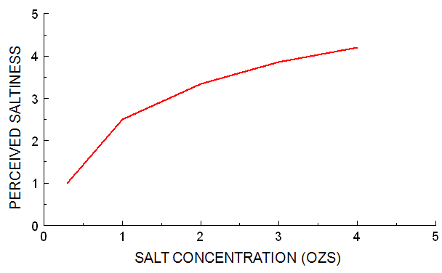

Log Scale

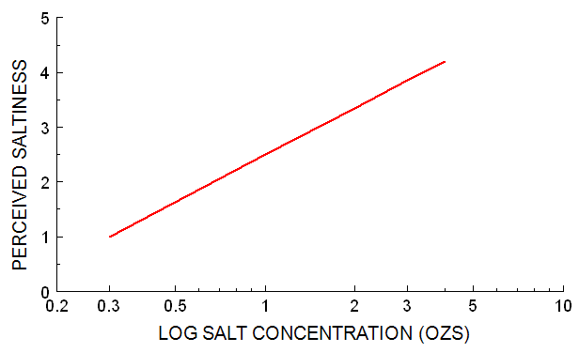

What this means in practice is that perceived saltiness does not double in relation to the doubling of salt. The relationship is such that disproportionately increasing amounts of salt are required to increase saltiness perception in a regular linear fashion.

This law is extended by an additional principle known as the Weber Ratio, which is in essence a measure of discriminability of stimuli (i.e. how much increase or decrease in particular stimulus is necessary before the subject can determine a difference from the original). The principal measure used in the Weber ratio is the J.N.D. (Just Noticeable Difference), which is defined as the difference between two stimuli that produces halfway to perfect discrimination (75% correct).

Preparation of Stimulus

For a Psychophysical Analysis to succeed, it is essential to test stimuli that have a perceived difference to the consumer. If the consumer is unable to make a difference between the different levels of the physical parameter (amount of salt), then responses towards the stimulus are not effective to determine the relation between the physical parameter and consumer response.

Measurement of Consumer Response

It is also essential to ensure that the basis for the consumer response (scale/attribute) is relevant to the physical parameter being changed. In our example, if the change in stimuli is ‘Amount of Salt’, it is not relevant to measure consumer response on ‘Bitterness’ of the stimuli.

5. | PRE-REQUISITES OF A PPA
 | 5.1. | PPA IN THE CIGARETTE CONTEXT

Despite the potential value of these measures in the cigarette industry, the use of PPA has been limited as an unwieldy number of stimulus evaluations per respondent are typically required to control bias. However, the ORACLE PPA method has been developed and validated to provide actionable data from as few as 5 cigarettes per subject.

 | 5.2. | PREPARATION OF THE EXEMPLARS

For each attribute a series of cigarettes need to be manufactured which systematically manipulate levels of the attribute in question whilst maintaining levels of all other attributes reasonably constant. The series should include the kind of levels of the attribute which would be current in the market and range substantially above and below this approximate level. The magnitude intervals between stimuli themselves only need to approximate equal 'steps'. This is not a critical factor.

While preparing the exemplars, one should ensure that there is adequate differentiation between the different levels of the attribute tested. This can be done by doing a series of Triad Tests (using Blind Samples) before conducting the actual PPA. The Triad tests can be done among a sample of respondents or, among the ‘expert panel’.

All combinations of the exemplars are not required to be tested in the Triads. Each exemplar needs to be tested only with the immediate level above and below. For example, if there are 5 exemplars – A > B > C > D > E, then the Triads to be done are:

- A Vs. A Vs. B, B Vs. B Vs. A

- B Vs. B Vs. C, C Vs. C Vs. B

- C Vs. C Vs. D, D Vs. D Vs. C

- D Vs. D Vs. E, E Vs. E Vs. D

Based on the Triads, only the differentiated exemplars should be measured in the PPA.

 | 5.3. | ATTRIBUTE TO BE TESTED

The attributes to be evaluated in a PPA must be ones which vary in a linear-continuous fashion as opposed to those attributes which are subject to abrupt complete failure. As mentioned before, for each attribute a series of cigarettes need to be manufactured which systematically manipulate levels of the attribute in question whilst maintaining levels of all other attributes reasonably constant.

In the context of cigarettes, however, changing a specific parameter can have an impact on multiple sensory parameters. For this reason, it is essential to conduct a PPA for each of the Sensory Attributes expected to be impacted by the change in the manufacturing attribute. For example, a change in ‘Ventilation’ can lead to a change in Draw Effort. But it can also impact Mouthful of Smoke or Irritation. In such a case, there is a need to do separate PPAs among the same respondents for each of the attributes.

6. | METHODOLOGY
 | 6.1 | INTERVIEW STRUCTURE AND RATING PROCEDURE

The interview is held in one session. The method is designed to evaluate one attribute at a time, although it is possible to evaluate more than one in sequence (but only one Sensory attribute in each session).

The interview structure is displayed below, with an example of the evaluation of one attribute.

SCREENING | è | Questions to ensure that the respondents fulfil the eligibility and quota requirements.
⬇
FIRST PRODUCT EVALUATION | è | Product evaluation. Rating of attribute level.
⬇
SECOND PRODUCT EVALUATION | è | Product evaluation. Rating of attribute level.
⬇
THIRD PRODUCT EVALUATION | è | Product evaluation. Rating of attribute level.
⬇
FOURTH PRODUCT EVALUATION | è | Product evaluation. Rating of attribute level.
⬇
FIFTH PRODUCT EVALUATION | è | Product evaluation. Rating of attribute level.

Each consumer is paired with an interviewer who always presents a cigarette with a moderate level of the attribute in the first evaluation. Thereafter, the order of presentation of the remaining cigarettes is dictated by response to the previous cigarette, according to some simple rules.

The respondent is asked to rate the given cigarette on a scale that has an ideal midpoint and extreme rejection limits.

SO LOW I WOULD NEVER CHOOSE TO SMOKE IT |  | IDEAL |  |  | SO HIGH I WOULD NEVER CHOOSE TO SMOKE IT

The interviewer is required to select each successive cigarette in a way that they would anticipate should produce a rating from the consumer roughly equal and opposite on the 'other' side of the ideal point, while avoiding giving extreme stimuli too early on in the sequence.

An ideal - typical sequence might therefore be:

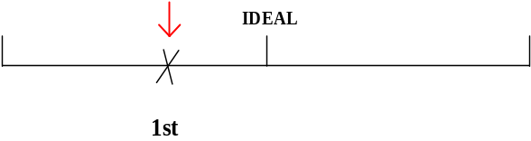

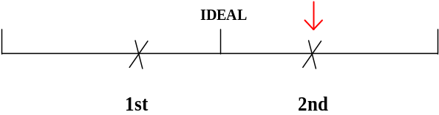

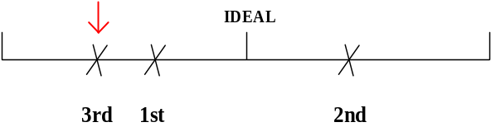

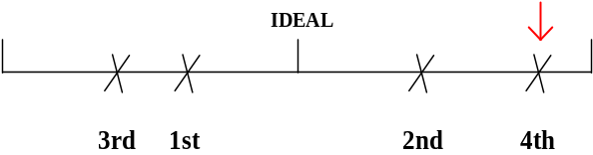

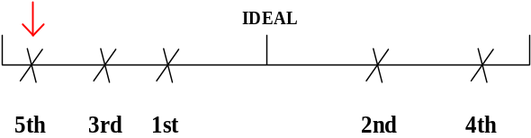

This simple procedure ensures that responses are anchored on a familiar referent, that extreme stimuli are avoided in the early stages of the test, and that order of presentation is balanced (i.e. not progressively getting stronger or weaker). This is a bias minimising procedure, i.e. it radically reduces normal biasing effects of end scale, mid scale and presentation order which normally contribute to the requirement in conventional psychophysics to use very large samples and stimulus presentations.

 | 6.2. | DEFINITIONS OF ATTRIBUTES AND REJECT LIMITS

Each scale is presented together with the attribute definition in order to ensure that the consumer is reminded of what the attribute refers to. This has the effect of improving consistency of attribute definitions across the consumer sample.

Each attribute has a name (e.g. "Cigarette Firmness") and scaling labels (e.g. "So loosely packed I would never choose to smoke it" - "Ideal" - "So tightly packed I would never choose to smoke it") together with a standard definition. Typical scale presentations therefore appear as follows:

CIGARETTE FIRMNESS: The judgement of how loosely or tightly filled the tobacco tube is. It is judged by the feel of the cigarette when rolled between the fingers.

SO LOOSELY PACKED I WOULD NEVER CHOOSE TO SMOKE IT |  | IDEAL |  |  | SO TIGHTLY PACKED I WOULD NEVER CHOOSE TO SMOKE IT

 | 6.3. | SAMPLING

Sampling composition depends on the project objectives. The total sample size will depend on the number of split cells. The usual splits are Lights/F.F., International brands/Local brands, Males/Females etc. The minimum sample size is 120 per split cell for highly homogeneous groups. If there is any evidence of lack of homogeneity, the minimum required size is 200 per cell.

7. | ANALYSIS
 | 7.1. | SOFTWARE

The data processing and analysis should be conducted with the BAT ORACLE proprietary software PPA.exe.

 | 7.2. | PROCEDURE

Although the software itself will conduct the data processing and analysis, this Section will explain the basic analysis procedure.

Based upon the classical psychophysical model for each individual respondent a linear regression between sensory magnitude scores and log physical attribute can be plotted.

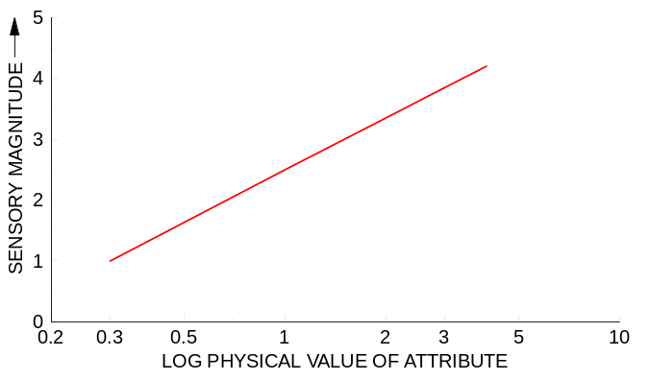
In this classical case the function describes the relationship of the attribute physical amount to the resultant perception. However there is no ability to make any inference about what is ideal, what is rejected or what is the tolerance range.

The innovation of the ORACLE approach lies in the fact that the scale used by the respondent is not a simple sensory magnitude scale (as in vertical axis above) but already includes ideal and rejection limit reference points.

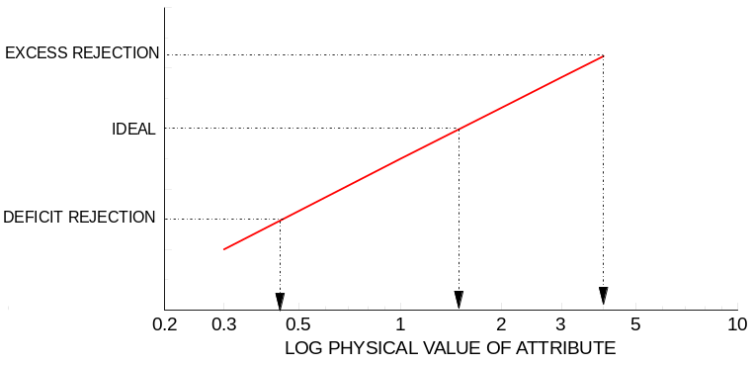

The JND (Just Noticeable Difference) can be now computed, although it can now rightly be called JTD (Just Tolerable Difference) since we observe that it falls inside of the defined rejection limits. The JTD represents the points at which the respondents would be predicted to be capable of distinguishing that a stimulus is different from the Ideal either because it has a higher (+ 1 JTD) or a lower (-1 JTD) concentration of the attribute(). However, this difference is still tolerable by definition.

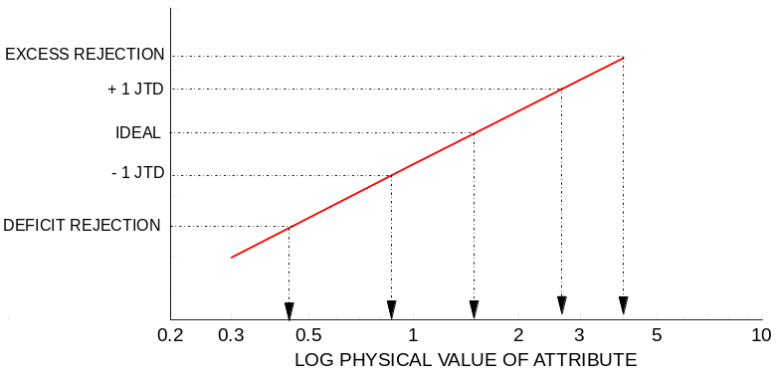

Individual data is then aggregated and cumulative frequencies plotted on a tolerance triangle diagram, which forms the data output for the study.

The tolerance triangle consist of the following components.

n Deficit rejection limits: Cumulative individual deficit rejection limits, i.e. the point at which the attribute level is so low that consumers would reject the product. For example, if the attribute measured was Menthol level among menthol cigarette smokers, the chart would look like the one below:

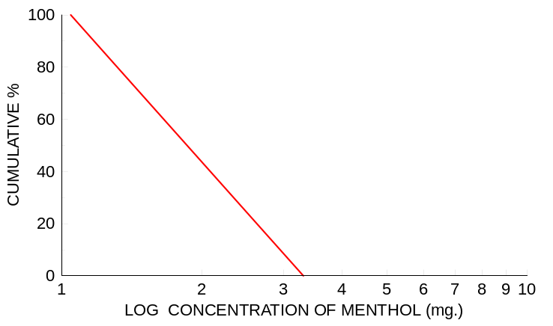

Taking the hypothetical example, below we can see that 42% of consumers would reject a cigarette as having too little Menthol at a physical value of 2 mg.

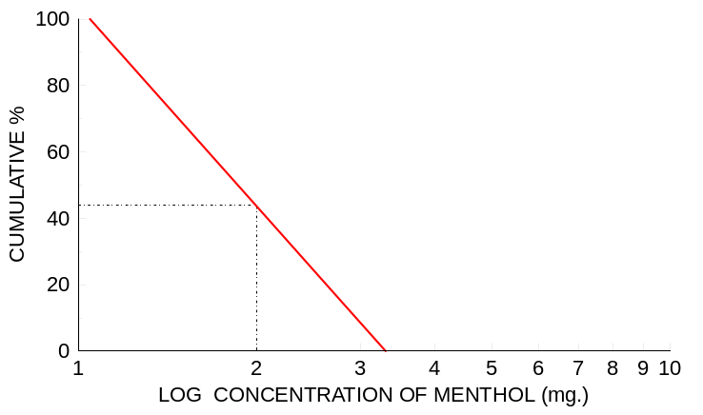

n Excess rejection limits: Cumulative individual excess rejection limits, i.e. the point at which the attribute level is so high that consumers would reject the product. These are plotted on the same base as the deficit rejection limits.

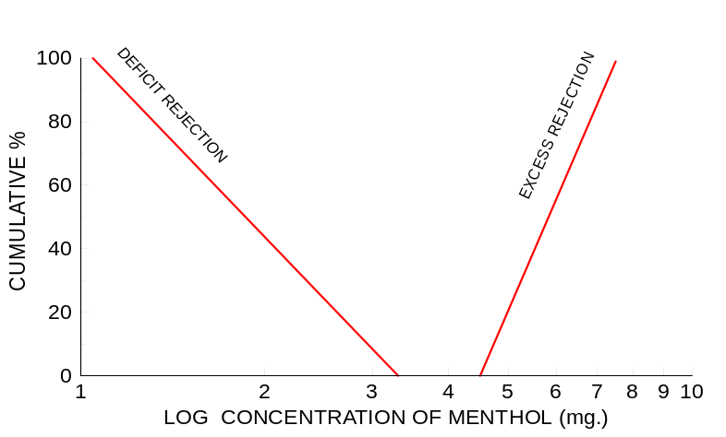

Following through on this hypothetical example, we can see that 54% of consumers would reject a cigarette as having too much Menthol at a physical value of 6 mg.
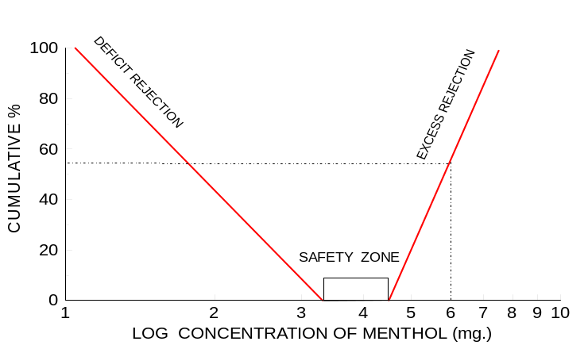

The zone of absolute safety lies between the excess and deficit rejection limits. Levels within this range of the physical attribute would not prompt actual rejection behaviour from any consumer regarding this particular attribute. In this example it lies between 3.3 and 4.5 mg.

n Ideal + 1 JTD and ideal - 1 JTD: Cumulative individual ideal plus/minus 1 JTD limits.

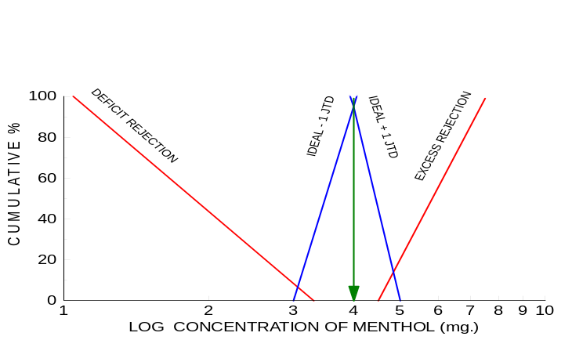

The practical significance of plotting the Ideal +/- 1 JTD is that if a perpendicular is dropped from their intersection to the longitudinal axis it will define the median ideal value for the physical attribute for the consumer sample. In this hypothetical example, the ideal point lies around 4 mg. menthol.

 | 7.3. | DECISION CRITERIA

As mentioned before, for each manufacturing attribute tested, there may be multiple sensory or physical attributes that can be impacted. So, a PPA needs to be done for each of the Physical and Sensory attributes expected to be impacted. Given such a situation, there needs to be specific criteria set for decision making based on the outcomes of a PPA exercise.

The decision criteria are at 2 levels.

At the first level, only the attributes that have the highest level of consistent ratings are selected. A consistent rating is when a respondent rates the exemplars in the same hierarchy as the physical parameter. So, if there are 5 exemplars tested, where A > B > C > D > E, then the ratings on that attribute should follow the same hierarchy. Any attribute with significantly lower consistency vs. the most consistent attribute are not considered for decision making.

Among the Consistent attributes, the attribute where the tolerance range is the lowest will be considered for decision making.

8. | APPENDICES

8.1. Standard Attribute List

8.2. Questionnaire and Stimuli Examples

8.3. Full Case Example

(?) As such, it is a measure of dispersion from the Ideal point.

